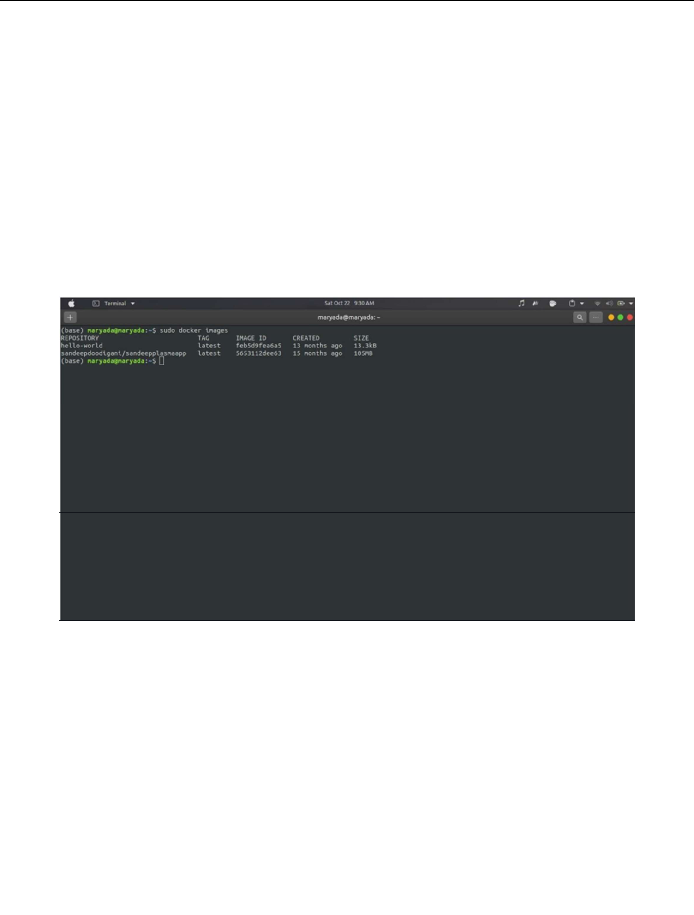
Assignment 4

Kubernetes / Docker

Inventory Management Application:

Team ID : PNT2022TMID05660

Name : Mohamed Fazil

1.Pull an Image from docker hub and run it in docker playground.
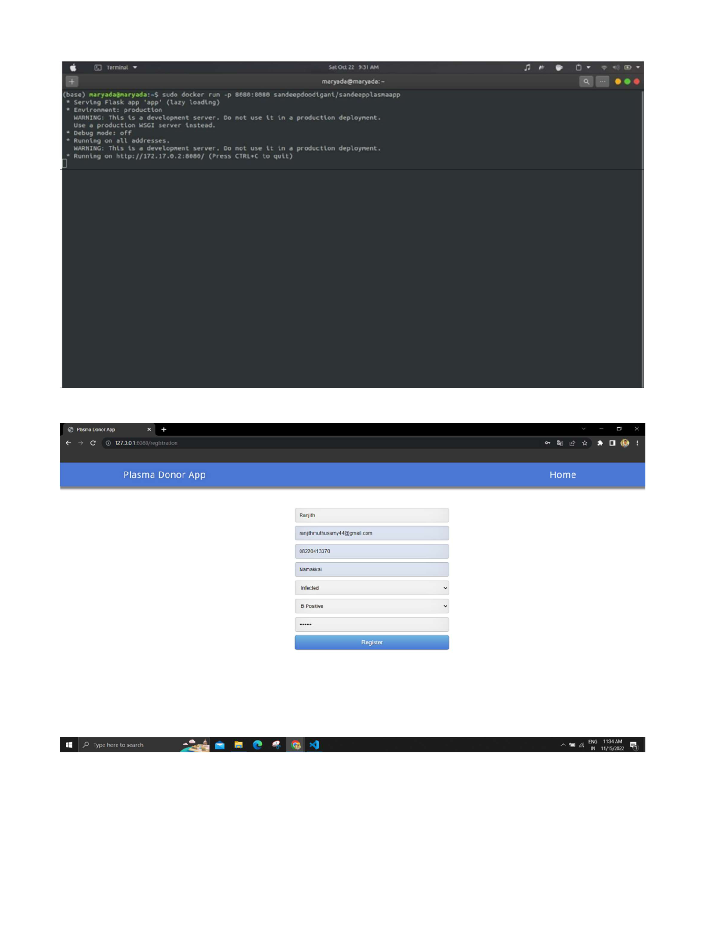
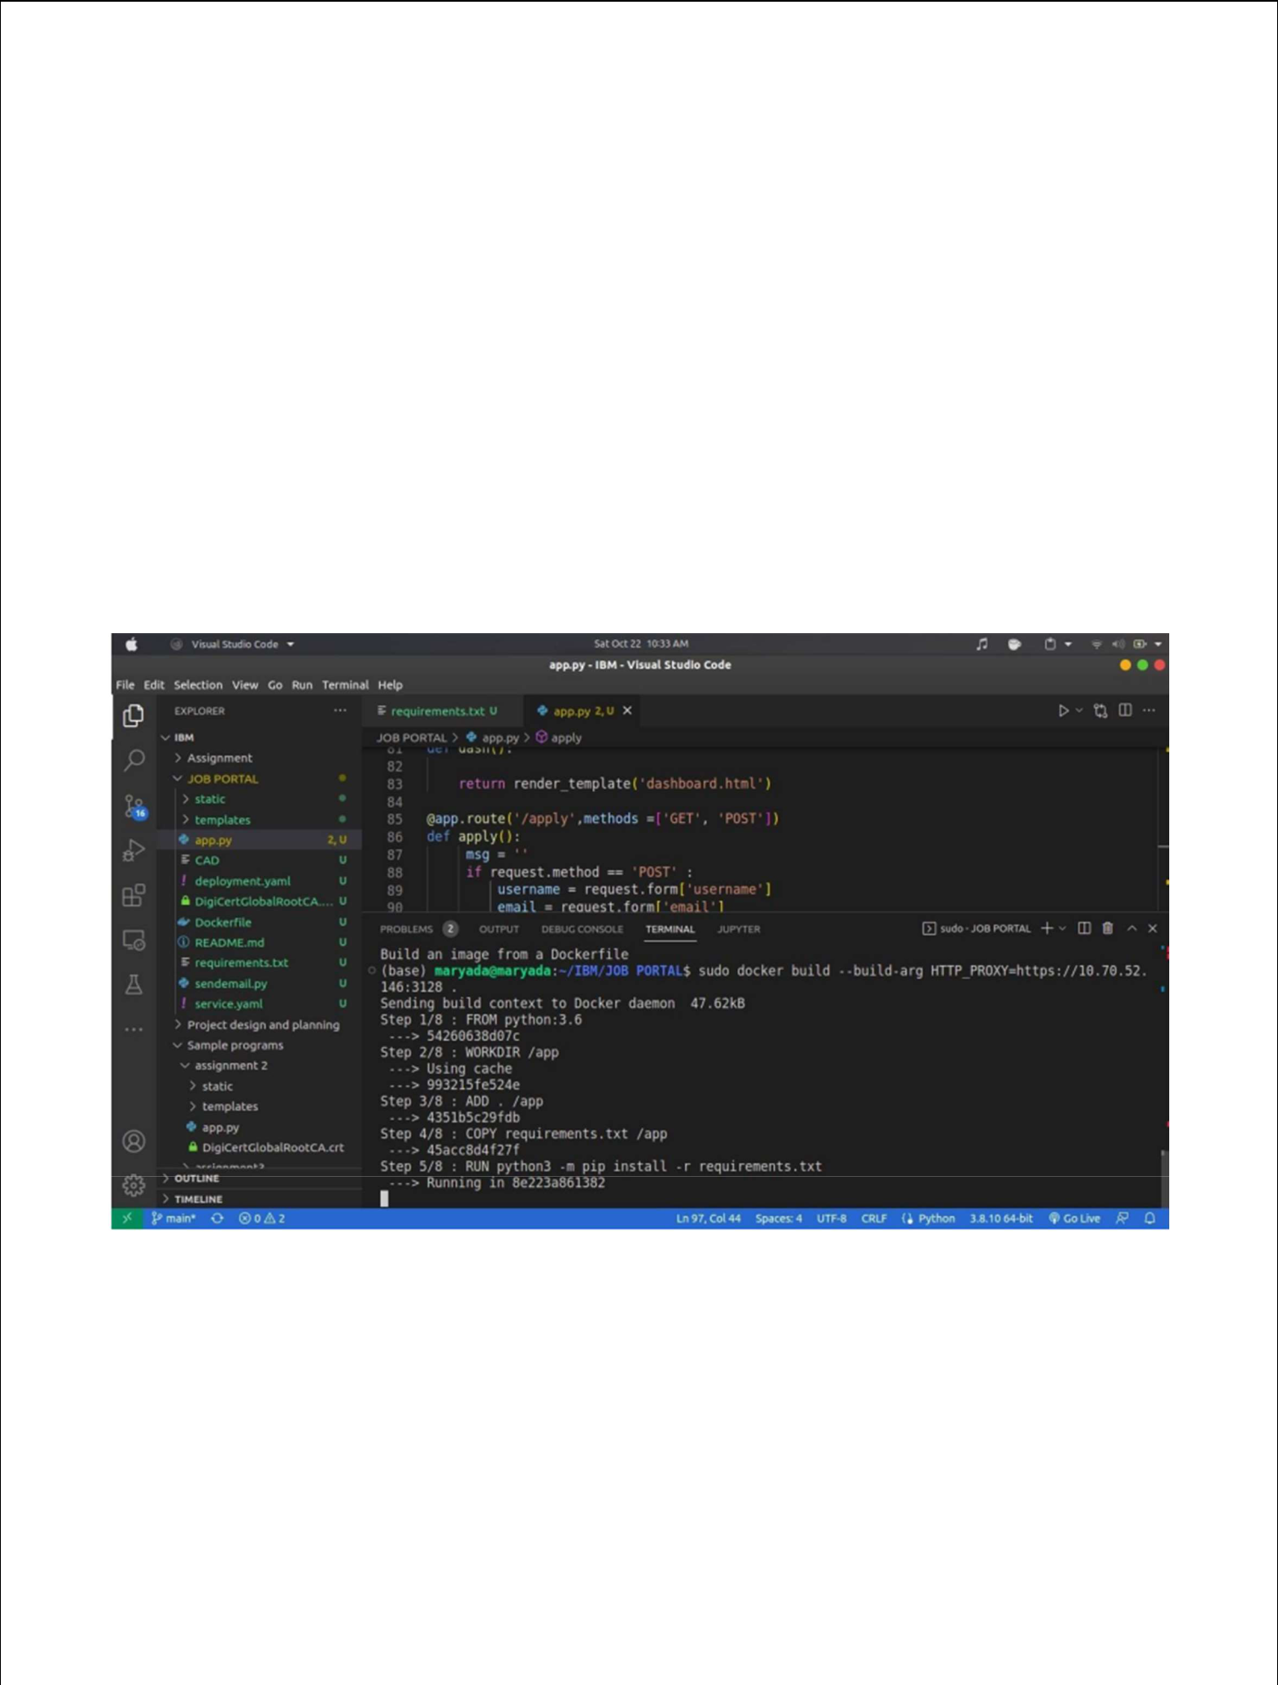
2.Create a docker file for the jobportal application and deploy it in Docker desktop application.

Dockerfile:

FROM python:3.6

WORKDIR /app

ADD . /app

COPY requirements.txt /app

RUN python3 -m pip install -r requirements.txt

RUN python3 -m pip install ibm_db

EXPOSE 5000

CMD ["python","app.py"]
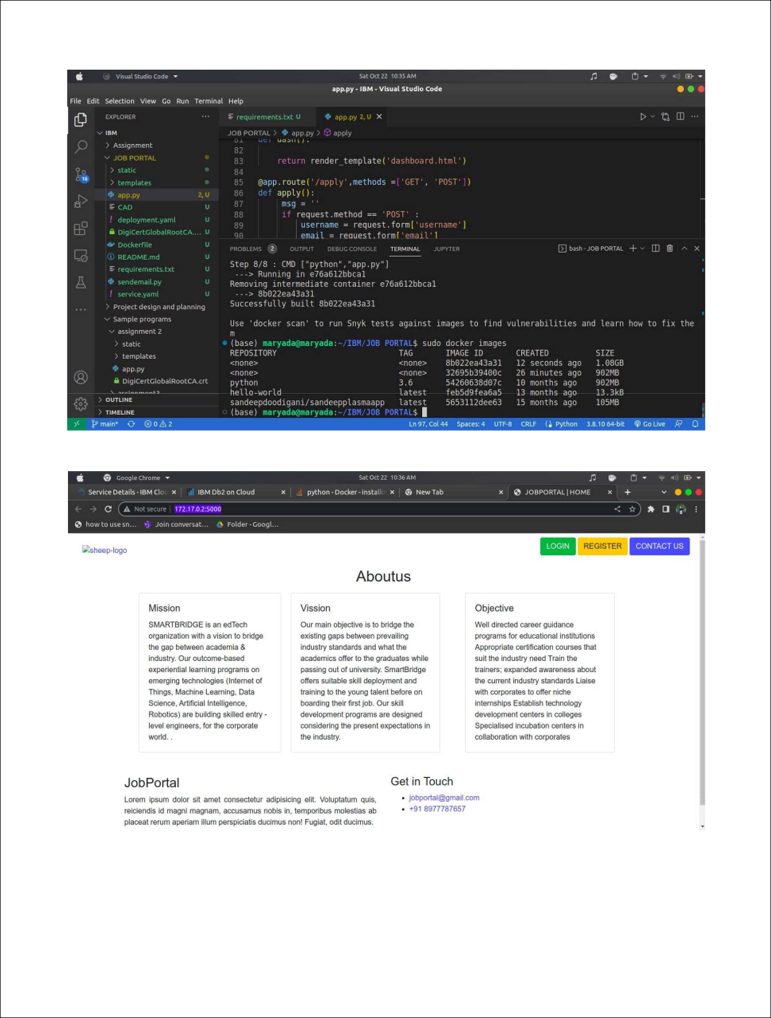
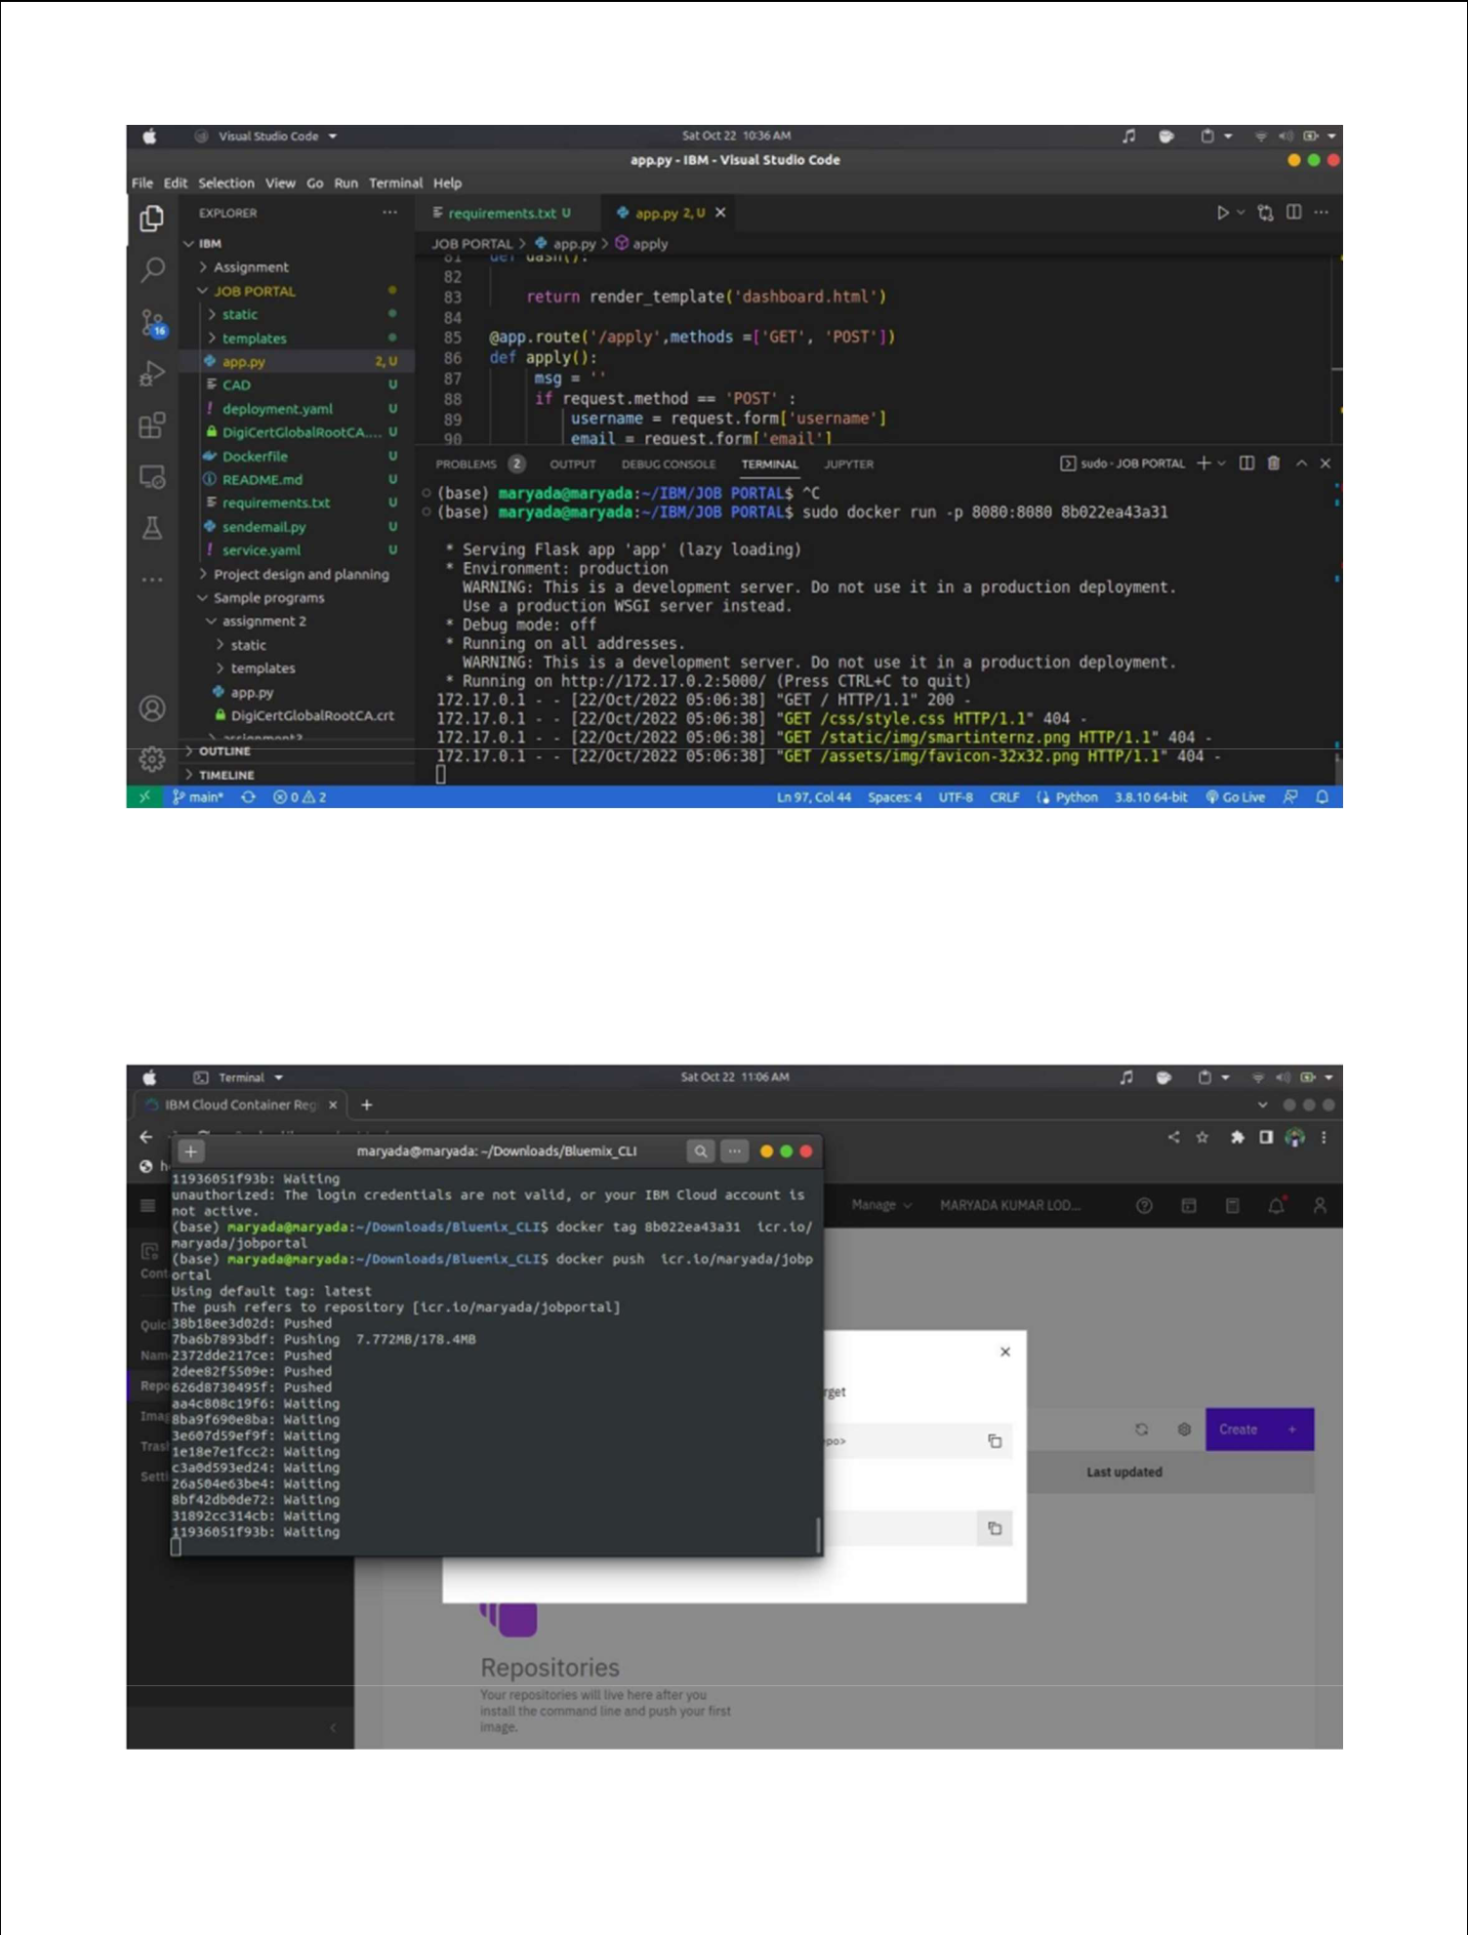

3.Create a IBM container registry and deploy helloworld app or jobportalapp.
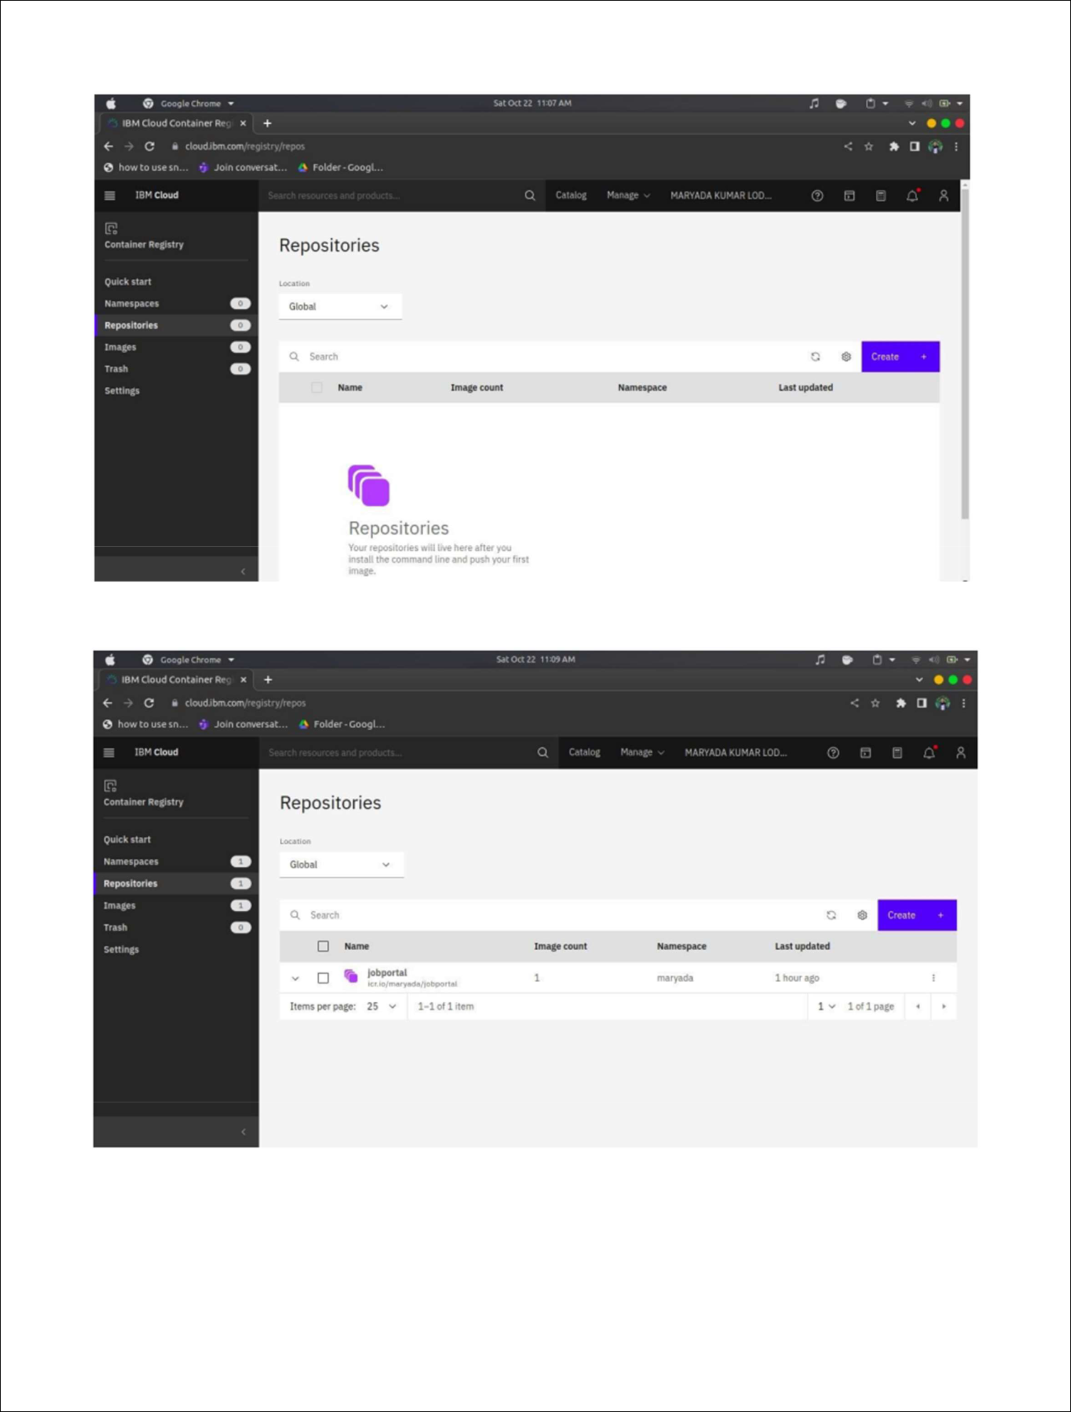
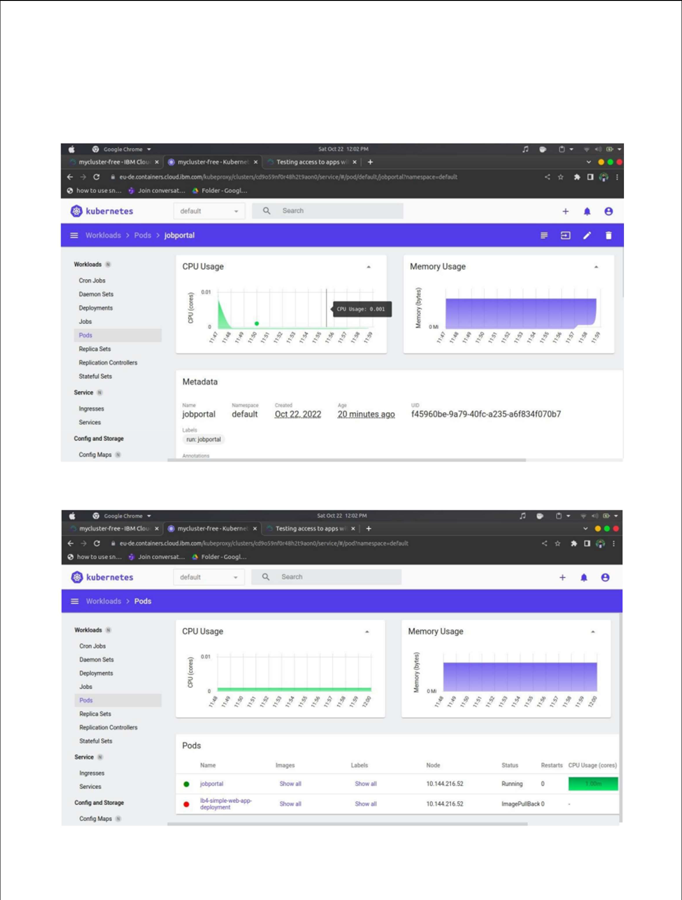
4.Create a Kubernetes cluster in IBM cloud and deploy helloworld image or jobportal image and also expose the same app to run in nodeport.

